**Year 10 General Science Geology Mid Topic**

**Astronomy Test**

/37

**Name:____________________________________**

**Multiple Choice Answer Sheet**

1. A B C D 13. A B C D

2. A B C D 14. A B C D

3. A B C D 15. A B C D

4. A B C D 16. A B C D

5. A B C D 17. A B C D

6. A B C D 18. A B C D

7. A B C D 19. A B C D

8. A B C D

9. A B C D

10. A B C D

11. A B C D

12. A B C D

**1** A light year is a measure of

A time

B distance

C speed

D brightness

**2** Light years used in astronomy because

A The stars are too bright to measure using other methods

B They are out of the earth’s atmosphere

C The distances are so large

D Things take a long time to happen in space

3 A light year is 9.5 trillion km (9500000000000km).

Proxima [Centauri](http://www.astro.wisc.edu/~dolan/constellations/constellations/Centaurus.html) is the closest star (besides the sun) to earth, it is 4.2 light years away. This means it:

A would take 39.9 years to get there

B it takes the light from the star 39.9 years to reach earth

C it is 39.9 trillion km away from earth

D it is part of our solar system

4 The distance unit used by most astronomers is the parsec. One parsec corresponds to a bit more than 3 light years. If a galaxy is 2.5 million parsecs from us, about how long does light from that galaxy take to reach us?

A 8 million years

B 5 million years

C 3 million years

D there is not enough information to work that out.

5 A light year is defined as …

A the distance light travels from the closest star.

B the distance from Alpha Centauri to the sun.

C the distance of the Earth from the sun.

D the distance light travels in a year.

6. The main fuel of stars is …

A hydrogen.

B helium.

C carbon.

D gold.

7 Clouds of gas and dust that form spectacular images are _____.

A stars.

B nebulae.

C planets.

D suns.

8 When a star the size of our sun begins to run out of fuel, it transforms and swells

in size until it becomes a _____.

A white dwarf.

B red giant.

C red dwarf.

D white giant.

9 Which one of the following gives the correct order of size from smallest to largest?

A universe, planet, galaxy, solar system

B planet, solar system, galaxy, universe

C planet, galaxy, solar system, universe

D galaxy, universe, planet, solar system

10 The Milky Way is most accurately described as a _____.

A planet.

B universe.

C solar system.

D galaxy.

11 The major source of energy in the Sun is:

A electrical.

B chemical.

C nuclear.

D magnetic.

12 Many scientists expect that Man will travel to other planets in the solar system within the next 100 years. However, they do not think that Man will travel to planets of other stars in the universe in the next 100 years.

The main reason that trips to planets of other stars in this period are unlikely is that scientists:

A don’t know which stars have planets.

B fear that the planets may have strange life forms, which could harm the astronauts.

C doubt that there are any other stars that have planets.

D realise that such trips would take too long because the distances are so great.

13 Which of the following it NOT true about black holes

A The gravitational field is so strong not even light can escape

B They are only formed when very hot stars die

C They are at the centre of most galaxies

D They emit a high energy X ray signal

14. Most galaxies are moving away from our own galaxy. This is evidence that:

A the Universe is expanding

B our galaxy is the centre of the Universe

C our galaxy exerts a repulsion force on other galaxies

D new galaxies are forming near ours

15 Which of the following statements about the life cycles of stars is true?

A The least massive stars use up their hydrogen fuel the fastest.

B The most massive stars use up their hydrogen fuel the fastest.

C The stars with the least number of planets use up their hydrogen fuel the fastest.

D The stars with the greatest number of planets use up their hydrogen fuel the fastest.

16 Patterns of stars in the night sky are called _____.

A asteroids

B galaxies

C nebulae

D constellations

17 Which of the following is the closest to the number of galaxies Astronomers can detect in the universe?

A Hundreds

B Thousands

C Millions

D Billions

18 The sun (and other stars) get their energy from nuclear fusion. Which of the following is **INCORRECT** about nuclear fusion in stars?

A It usually involves hydrogen

B Atoms are blown apart by the enormous heat

C Fusion is where two atoms are joined together by enormous pressure

D It is what makes the energy which is released from the sun

19 Which of the following is **true** about our sun?

A Our sun will turn in to a red giant in the near future

B Our sun is a main sequence star

C Our sun may become a black hole or neutron star in the future

D Our sun is a small star

**Short Answer**

1 Label each of the diagrams below using one of the following words. You may use each word more than once:  **(8)**

*Main Sequence Star, Nebula, Red Giant, Supa Nova, Black Hole, White Dwarf,*

*Black Dwarf, Neutron Star*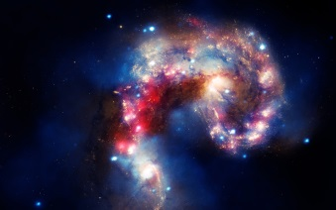

[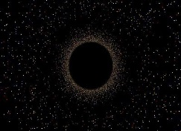](http://www.google.com.au/url?sa=i&rct=j&q=black+hole&source=images&cd=&cad=rja&docid=9BwRWwfM9SIWqM&tbnid=Em0muZuX9DhaeM:&ved=0CAUQjRw&url=http://abyss.uoregon.edu/~js/ast122/lectures/lec21.html&ei=-D9nUrvRKIWfkwWbx4DACA&psig=AFQjCNE_qDune-RIuejtiQh6jCbEcb-Hlg&ust=1382584682521686)[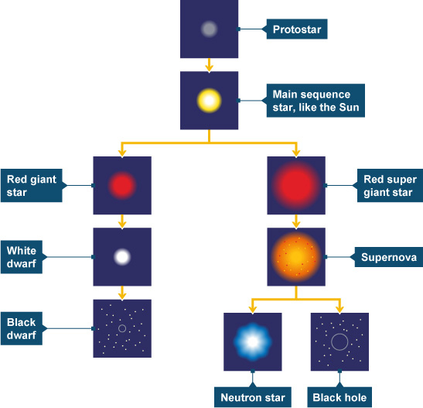](http://www.google.com.au/url?sa=i&rct=j&q=star+life+cycle+diagram&source=images&cd=&cad=rja&docid=1a4vE9H875vF2M&tbnid=llIAUmnHhH56uM:&ved=0CAUQjRw&url=/url?sa%3Di%26rct%3Dj%26q%3Dstar%2Blife%2Bcycle%2Bdiagram%26source%3Dimages%26cd%3D%26docid%3D1a4vE9H875vF2M%26tbnid%3DllIAUmnHhH56uM:%26ved%3D%26url%3Dhttp://www.bbc.co.uk/schools/gcsebitesize/science/add_aqa/stars/lifecyclestarsrev2.shtml%26ei%3DQCxnUsOAH8KHlAXVhYEQ%26psig%3DAFQjCNFUr1as7Fy_p7PMbm-BfRanK0vIxw%26ust%3D1382579648863157&ei=TixnUr-ePM3MkQXPvYHoDA&psig=AFQjCNFUr1as7Fy_p7PMbm-BfRanK0vIxw&ust=1382579648863157)

**B**

**A**

2 What causes the transition from point A in the diagram above to point B? **(1)**

3 Circle the pathway that would be followed by a star with more mass **(1)**

4 Astronomers have found that nearly all the galaxies in the universe are moving away from each other. What is the big bang theory and how does this evidence support it? **(3)**

5 Which American Astronomer was the first to find evidence that galaxies are moving away from each other? **(1)**

6 Before that discovery the “Steady State” model of the universe was most popular? What is the steady state model? **(1)**

7 Galaxies are classified according to their shape.  **(3)**

Draw lines to match the diagrams below with the description of their shape:

[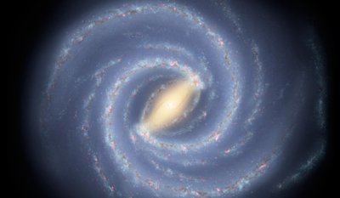](http://www.google.com.au/url?sa=i&rct=j&q=spiral+galaxies&source=images&cd=&cad=rja&docid=FbMrsFt9VxczaM&tbnid=he4Wlpl3cLl7tM:&ved=0CAUQjRw&url=http://physicsworld.com/cws/article/news/2011/apr/12/do-spiral-galaxies-form-from-the-inside-out&ei=DkpnUrCQE8SOkwXtkYDoBw&psig=AFQjCNEZBsHqJV9asZSe0cdPvbZQap2CbA&ust=1382587267321744) Elliptical

[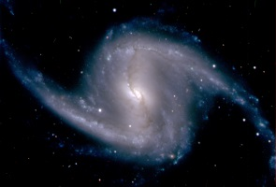](http://www.google.com.au/url?sa=i&rct=j&q=barred+spiral+galaxies&source=images&cd=&cad=rja&docid=T2vSda0iylz7YM&tbnid=DQU2Ra8Ucu_nuM:&ved=0CAUQjRw&url=https://news.slac.stanford.edu/features/first-images-dark-energy-camera-help-slac-stanford-astrophysicists-seek-invisible&ei=LkpnUt61FsmokQWovoD4BQ&psig=AFQjCNH9aUntkJW4BFJeucb02kQciaGnWQ&ust=1382587300510954) Spiral

[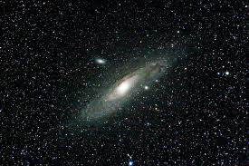](http://www.google.com.au/url?sa=i&rct=j&q=elliptical+galaxies&source=images&cd=&cad=rja&docid=LtwgEajVtQgSEM&tbnid=PSGATOu5eaUucM:&ved=0CAUQjRw&url=http://www.smallmadtv.com/m110.htm&ei=b0pnUrm8OMSmlQWf4IGAAQ&psig=AFQjCNH5GESy1qc0gNumpyUk41cdX28oTw&ust=1382587365838007) Barred Spiral

**Year 10 General Science Geology Mid Topic**

**Astronomy Test**

**SOLUTIONS**

1. A B C D 13. A B C D

2. A B C D 14. A B C D

3. A B C D 15. A B C D

4. A B C D 16. A B C D

5. A B C D 17. A B C D

6. A B C D 18. A B C D

7. A B C D 19. A B C D

8. A B C D

9. A B C D

10. A B C D

11. A B C D

12. A B C D

**Short Answer**

1 Label each of the diagrams below using one of the following words. You may use each word more than once: (8)

*Main Sequence Star, Nebula, Red Giant, Supa Nova, Black Hole, White Dwarf,*

*Black Dwarf, Neutron Star*

Nebula

Main sequence

Red Giant

Supa nova

[](http://www.google.com.au/url?sa=i&rct=j&q=black+hole&source=images&cd=&cad=rja&docid=9BwRWwfM9SIWqM&tbnid=Em0muZuX9DhaeM:&ved=0CAUQjRw&url=http://abyss.uoregon.edu/~js/ast122/lectures/lec21.html&ei=-D9nUrvRKIWfkwWbx4DACA&psig=AFQjCNE_qDune-RIuejtiQh6jCbEcb-Hlg&ust=1382584682521686)[](http://www.google.com.au/url?sa=i&rct=j&q=star+life+cycle+diagram&source=images&cd=&cad=rja&docid=1a4vE9H875vF2M&tbnid=llIAUmnHhH56uM:&ved=0CAUQjRw&url=/url?sa%3Di%26rct%3Dj%26q%3Dstar%2Blife%2Bcycle%2Bdiagram%26source%3Dimages%26cd%3D%26docid%3D1a4vE9H875vF2M%26tbnid%3DllIAUmnHhH56uM:%26ved%3D%26url%3Dhttp://www.bbc.co.uk/schools/gcsebitesize/science/add_aqa/stars/lifecyclestarsrev2.shtml%26ei%3DQCxnUsOAH8KHlAXVhYEQ%26psig%3DAFQjCNFUr1as7Fy_p7PMbm-BfRanK0vIxw%26ust%3D1382579648863157&ei=TixnUr-ePM3MkQXPvYHoDA&psig=AFQjCNFUr1as7Fy_p7PMbm-BfRanK0vIxw&ust=1382579648863157)

Minus 1 for each incorrect / missing

Neutron star Black Hole

Red Giant

White dwarf

Black Dwarf

**B**

**A**

2 What causes the transition from point A in the diagram above to point B? (1)

Runs out of Hydrogen/fuel

3 Circle the pathway that would be followed by a star with more mass (1)

4 Astronomers have found that nearly all the galaxies in the universe are moving away from each other. What is the big bang theory and how does this evidence support it? (3)

All mass began in one place 1

Big explosion/ big bang 1

Everything still moving away 1

5 Which American Astronomer was the first to find evidence that galaxies are moving away from each other? Edwin Hubble (or just Hubble) (1)

6 Before that discovery the “Steady State” model of the universe was most popular? What is the steady state model? (1)

That everything in the universe has always been about where it is now

7 Galaxies are classified according to their shape. (3)

Draw lines to match the diagrams below with the description of their shape:

[](http://www.google.com.au/url?sa=i&rct=j&q=spiral+galaxies&source=images&cd=&cad=rja&docid=FbMrsFt9VxczaM&tbnid=he4Wlpl3cLl7tM:&ved=0CAUQjRw&url=http://physicsworld.com/cws/article/news/2011/apr/12/do-spiral-galaxies-form-from-the-inside-out&ei=DkpnUrCQE8SOkwXtkYDoBw&psig=AFQjCNEZBsHqJV9asZSe0cdPvbZQap2CbA&ust=1382587267321744) Elliptical

[](http://www.google.com.au/url?sa=i&rct=j&q=barred+spiral+galaxies&source=images&cd=&cad=rja&docid=T2vSda0iylz7YM&tbnid=DQU2Ra8Ucu_nuM:&ved=0CAUQjRw&url=https://news.slac.stanford.edu/features/first-images-dark-energy-camera-help-slac-stanford-astrophysicists-seek-invisible&ei=LkpnUt61FsmokQWovoD4BQ&psig=AFQjCNH9aUntkJW4BFJeucb02kQciaGnWQ&ust=1382587300510954) Spiral

[](http://www.google.com.au/url?sa=i&rct=j&q=elliptical+galaxies&source=images&cd=&cad=rja&docid=LtwgEajVtQgSEM&tbnid=PSGATOu5eaUucM:&ved=0CAUQjRw&url=http://www.smallmadtv.com/m110.htm&ei=b0pnUrm8OMSmlQWf4IGAAQ&psig=AFQjCNH5GESy1qc0gNumpyUk41cdX28oTw&ust=1382587365838007) Barred Spiral